**Assignment -1**

Python Programming

|  |  |
| --- | --- |
| Assignment Date | 21st October 2022 |
| Student Name | Hariharan.P.K |
| Student Roll Number | 310819205036 |
| Maximum Marks | 2 Marks |

**Question-1:**

Write a program which will find all such numbers which are divisible by 7 but are not a multiple of 5, between 2000 and 3200 (both included). The numbers obtained should be printed in a commaseparated sequence on a single line.

Solution:

l=[]

for i in range(2000, 3201):

if (i%7==0) and (i%5!=0):

l.append(str(i))

print (','.join(l))

#----------------------------------------#

#----------------------------------------#

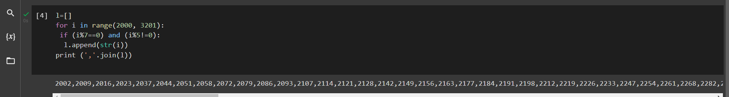

**Question-2:**

With a given integral number n, write a program to generate a dictionary that contains (i, i*i) such that is an integral number between 1 and n (both included). and then the program should print the dictionary.

Suppose the following input is supplied to the program:

8

Then, the output should be: {1: 1, 2: 4, 3: 9, 4: 16, 5: 25, 6: 36, 7: 49, 8: 64}

Solution:

n=int(input())

d=dict()

for i in range(1,n+1):

d[i]=i*i

print d

#----------------------------------------#

#----------------------------------------#

